
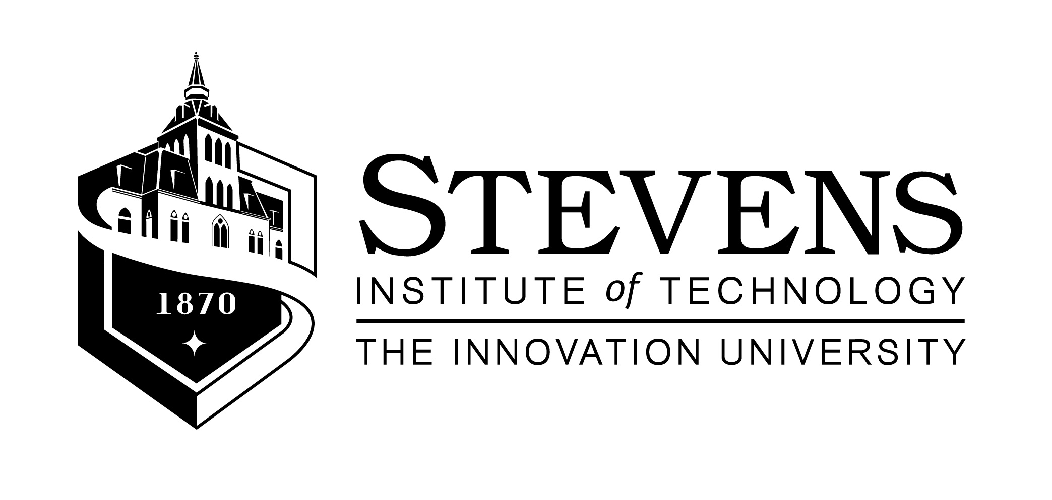

Immediate Media Release - Today’s Date: Nov. 8, 2011
Event Date: On Monday, November 14, 2011 ~ 6:00 pm to 9:00 pm
Registration & Reception: 6-7pm ~ Program: 7-9pm
FREE and open to the public.
The Light Millennium: www.lightmillennium.org
The College of Arts & Letters at Stevens: www.stevens.edu/cal

GENDER EQUALITY and EMPOWERING WOMEN:
MINORITY RIGHTS AND DISCRIMINATION

The Light Millennium, in collaboration with the College of Arts and Letters at Stevens Institute of Technology, presents a panel discussion on “Gender Equality and Empowering Women: Minority Rights and Discrimination," on Monday, November 14, 2011 at Stevens Institute of Technoloy, 228 Kidde Hall, 6th & River Streets, Hoboken, New Jersey.

Ambassador Palitha T. B. Kohona, permanent representative of Sri Lanka to the United Nations, and Ms. Ngone Diop, head of the Poverty and MGD Cluster in the United Nations Development Program, will be keynote speakers. The conference will also include a panel of distinguished guests, including Ms. Joycelyn Gill-Campbell, Organizational Coordinator, Domestic Workers United; Prof. Surendra Kaushik, Founder, Kaushik Women’s College in India; Dr. Sorosh Roshan, President, International Health Awareness Network; and Ms. Bircan Ünver, Founding President, The Light Millennium. Opening remarks will be made by Prof. Lisa M. Dolling, Dean of the College of Arts & Letters, and the panel will be moderated by Edward Foster, professor of history in the College.

Stevens College of Arts & Letters will host the program, which marks the 11th anniversary of The Light Millennium, a non-religious, non-political, not-for-profit, and non-governmental, independent public benefit multi-media and culture organization. Established in 2001, The Light Millenium has been associated with the Department of Public Information of the United Nations since December 2005.

ABSTRACT: Exploring Gender Equality and Empowering Women: this program will focus on the rights of, and discrimination against, minority women. It will also provide an opportunity to disseminate information about the programs and work of UN-Women, as well as to promote issues that are in line with Millennium Development Goal #3: Gender Equality and Empowering Women. The program also aims to encourage ideas for e-publishing from all walks of life in order to promote effectively and extensively the proposed theme.

This event is free and open to the public. Please RSVP to event@lightmillenium.org or visit http://www.lightmillennium.org/events/mdgs3_invite_Nov14_2011.pdf to learn more.
See also on Stevens Institute of Technology:
http://www.stevens.edu/news/content/gender-equality-and-empowering-women-minority-rights-and-discrimination
Brief Bios of the Participants:

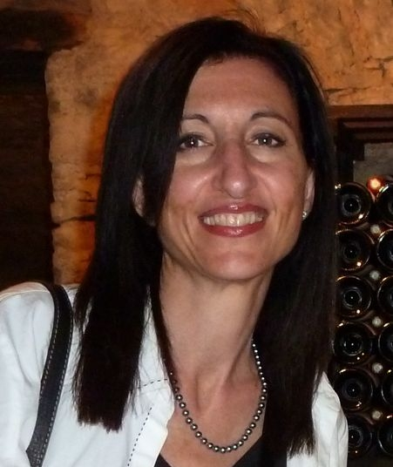 | Prof. Lisa M. Dolling, Ph.D., Dean, College of Arts and Letters, Stevens Institute of Technology – Opening Remarks  In addition to serving as Dean, Lisa Dolling is Associate Professor of Philosophy in the College of Arts and Letters at Stevens Institute of Technology. Her areas of expertise include the philosophy of science (specifically quantum theory), aesthetics, and feminist philosophy. She was the founding director of the Women’s Studies program at St. John’s University in NYC as well as the Gender and Cultural Studies program at Stevens. Dolling has published on such varied topics as the philosophical writings of Niels Bohr, Edith Stein, Simone Weil, and Ayn Rand. She Is the co-editor of The Tests of Time: Readings on the Development of Physical Theory (Princeton University Press) and has recently edited the volume Science, Technology and the Humanities: A New Synthesis. Dolling is currently working on a book-length project that focuses on the philosophical writings of American conservationist and scholar George Perkins Marsh.
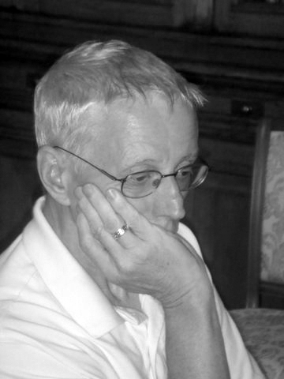 | Prof. Edward Foster, College of Arts & Letters, Stevens Institute of Technology - Moderator  Edward Foster is a professor of history and American Studies in the College of Arts and Letters. Former department head, director of humanities, and associate dean, he has also been a visiting professor at Drew University Graduate Faculty and Beykent University (Istanbul) and was a Fulbright lecturer at Haceteppe University in Ankara, Turkey, and at the University of Istanbul. Foster is the founding editor of Talisman: A Journal of Contemporary Poetry and Poetics, Talisman House, Publishers, and Jensen/Daniels, Publishers. He is a widely published critic, essayist, and poet, and his poetry has been translated into, and published in, many languages, including single-author volumes in Slovenian, Romanian, and Russian. His most recent publications, among more than twenty books and monographs, include his selected poems, What He Ought to Know and The Beginning of Sorrows. A new collection of his poetry, Dire Straits, is scheduled for publication this spring.
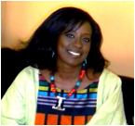 | Ms. Ngoné Diop, Head, Poverty and MGD Cluster, United Nations Development Program – Key Note Speaker - Ms. Diop leads the Cluster on Gender, Poverty, Growth and MDGs at UNDP. Ms. Diop is an economist and gender expert with 16 years of experience and a proven track record in poverty reduction strategies, economics, macroeconomics and public finance. Prior to joining the UNDP Gender Team, Ms. Diop served as Adviser and Economist in various regional and international organizations, including the UK Department for International Development (DFID), the Council for the Development of Social Science Research in Africa (CODESRIA), the World Bank, and the United Nations Economic Commission for Africa (UNECA). As a Senior Trainer and Researcher, Ms. Diop has conducted research and published extensively on gender and economics/macroeconomics, gender and poverty, gender budgeting and other gender and development policy issues. She is former Vice President of Akina Mama wa Afrika, an international NGO promoting the rights of African women.  *** Ms. Diop will be delivering her speech on behalf of Ms. Winnie Byanyima, Director, Gender Team, Bureau for Development Policy, UNDP
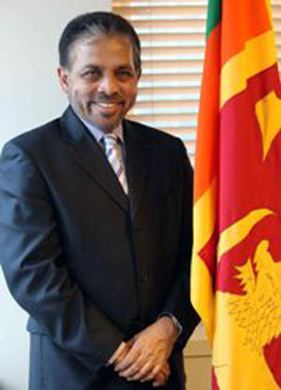 | Dr. Palitha T. B. Kohona, Ambassador, Permanent Representative of Sri Lanka to the U.N. – Key Note Speaker - Dr. Kohona served as the Secretary to the Ministry of Foreign Affairs of Sri Lanka until his appointment as Permanent Representative to the United Nations in New York. Prior to this he served as the Secretary-General of the Secretariat for Coordinating the Peace Process (SCOPP) established by the Government of Sri Lanka. Dr. Kohona was a member of the Sri Lanka delegation to the UN General Assembly from 2006 to 2010. He has led official level delegations to a wide range of countries on bilateral matters. He is currently the Co-Chair of the UN Ad-Hoc Working Group on Marine Resources beyond National Jurisdiction and is the Chairman of the Ad-Hoc Committee on the Indian Ocean. He is the Chair of the Special Committee to Investigate Israeli Practices Affecting the Human Rights of the Palestinian People and other Arabs of the Territories Occupied since 1967. He is also a Patron of the Sustainability Inc. and a Patron of the U Thant Institute. During his tenure as the Secretary-General of the Government Peace Secretariat (2006), he participated in several rounds of peace negotiations with the LTTE in Geneva and led the delegation to talks in Oslo.
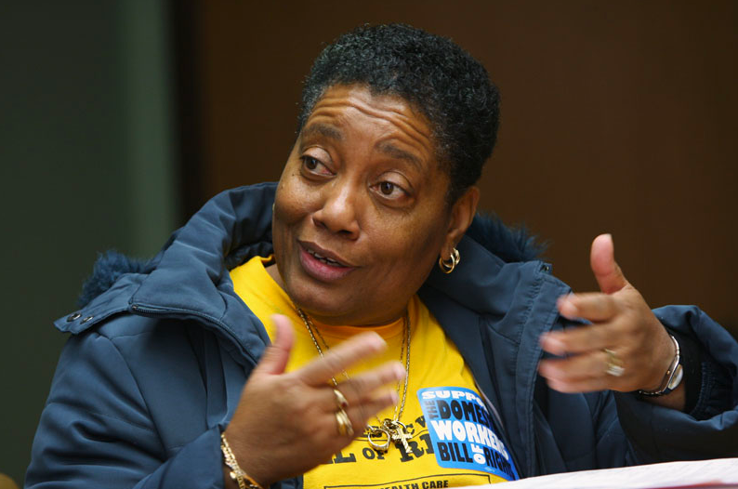 | Joycelyn Gill-Campbell, Organizational Coordinator, Domestic Workers United - Panelist  Ms. Gill-Campbell is the Organizational Coordinator with Domestic Workers United (DWU). She has been a member of DWU since 2002 and is a former nanny. She advocates against the exploitation and abuses that women face in the domestic industry and is currently working relentlessly in the Campaign for the Domestic Workers’ Bill of Rights. Ms. Gill-Campbell is a strong advocate for women’s rights and has spoken across the country on human rights and workers’ rights issues. A graduate of the Social Justice Leadership Foundations of Organizing Training Program and a current student at Cornell University, Ms. Gill-Campbell also serves on the Coordinating Committee of Grassroots Global Justice, a national alliance of grassroots organizations dedicated to building a transformative social justice movement across borders.
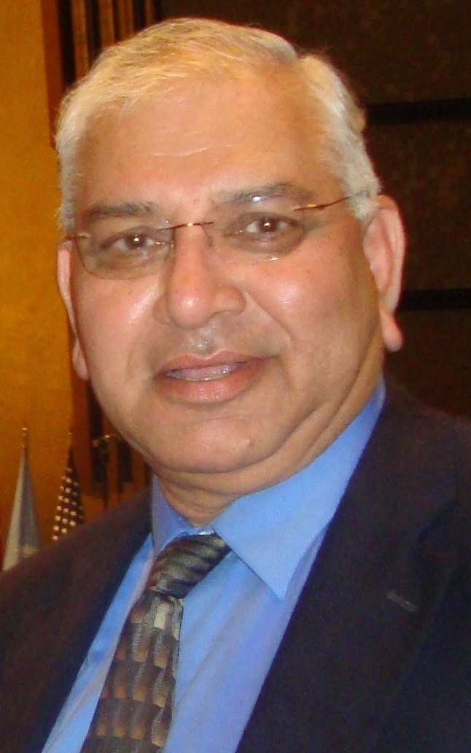 | Prof. Surendra K. Kaushik, Founder, Kaushik Women’s College in India - Panelist  Dr. Kaushik is chairman of the Helena Kaushik Education Foundation in New York, and founded the Mrs. Helena Kaushik Women’s College (www.helenakaushik.org) in India in 1999. The College is affiliated with the University of Rajasthan. The college has grown on a new 30-acre campus, and has graduated over 900 students with degrees like B.A. B. Sc, B. Sc in Biotechnology, B.Ed., M.A., and M.Sc. in Biotechnology. A documentary on the College can be viewed on the web under the name Mrs. Helena Kaushik Women’s College in four parts. Dr. Kaushik earned his Ph.D. in economics at Boston University in 1976 and has taught since 1981 at Pace University in New York, where he is a Professor of Finance in the Lubin School of Business.
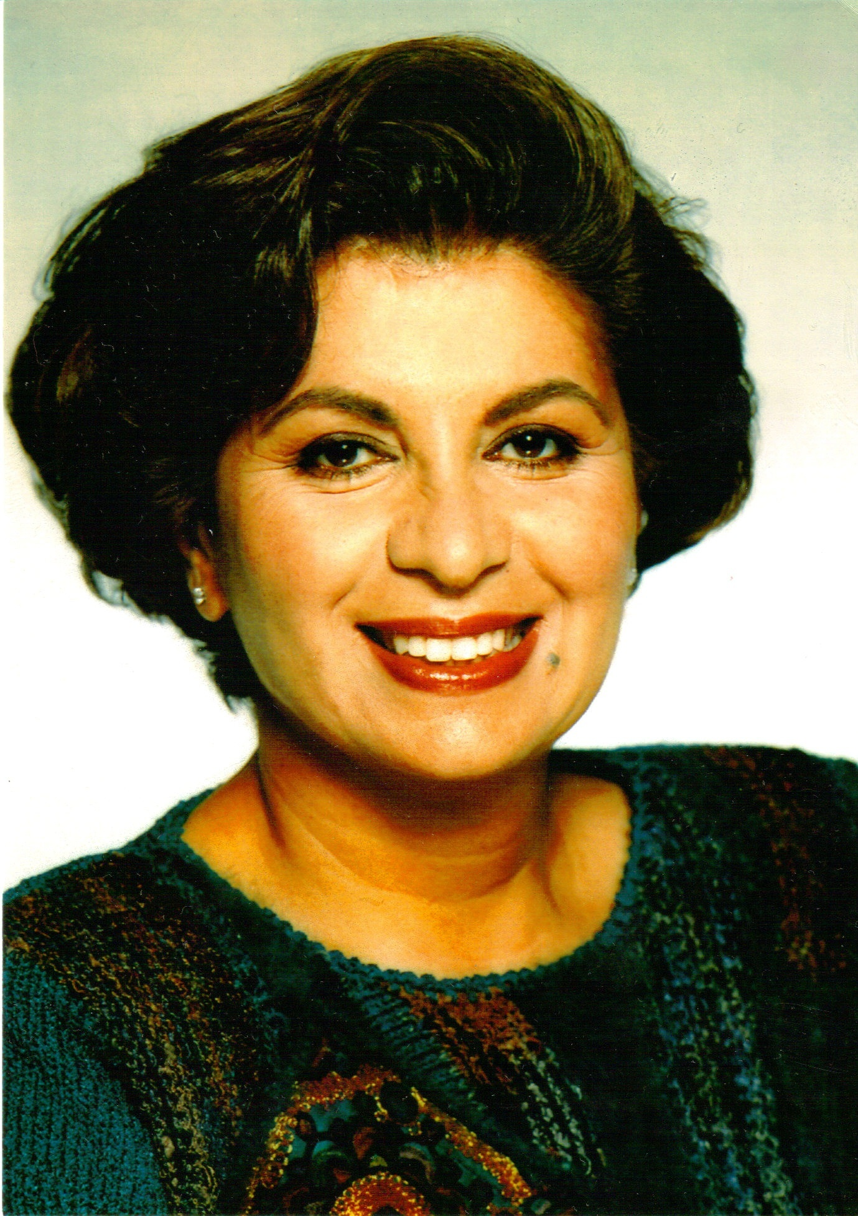 | Dr. Sorosh Roshan, M.D., MPH, FACOG President, International Health Awareness Network, NGO Rep. - Panelist  Dr. Roshan, a native of Iran, is Founding President of the International Health Awareness Notwork (www.ihan.orgis), and a Board Certified Obstetrician and Gynecologist with a Master’s Degree in Public Hhealth from New York University. She has served as Attending Physician at Overlook Hospital, Summit, NJ for 30 years, as Vice President of the International Council of Women, as President of the National Council of Women/U.S.A., and, currently, as Director of the Lehman College foundation. She is also on the Board of OICI, the Organization of Industrialization Centers International. As a Non-Governmental Organization's delegate to the United Nations since 1985, she has been on the forefront of issues affecting women throughout the world. Further, her fundraising efforts with the International Health Awareness Network have made it possible to conduct significant field projects in and for Kenya, Jordan, Ethiopia, Romania, Brooklyn, Ghana, Bangladesh, South Africa and Somaliland.
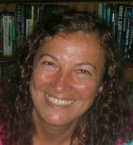 | Ms. Bircan Ünver, a Turkish native, is Originator (1999) and Founding President of The Light Millennium (LM, 2001), which is a public benefit and multi-media organization. She has been the executive producer and director of the LM, and LMTV programs since its inception, and is the permanent representative of the organization to the UN DPI since 2006. As an advocate for “freedom of expression” and “public benefit media,” she has compiled and e-published over 50 e-issues and produced over 75 original television programs, garnering several awards. She is also the founder of the ISIKBINYILI.ORG based in Istanbul, Turkey (January 2011), as a sister organization to the LM. Bircan holds a Master’s Degree in Media Studies of the New School University. Her thesis project was a half-hour video documentary titled “ALL IDEAS: Freedom of Expression in Turkey” (1999).

Target Audience:
Students and faculty of the Stevens Institute of Technology, local residents, civil society, non-governmental organizations and local media.

To all potential attendees of the panel:
We'd like you to be part of the discussion session following the panel, and to bring in your own experiences and ideas, regardless of your country of origin. This should be a forum for open discussion and reflection.

The presentations will be followed by a Q & A and networking session.

About The Light Millennium (http://www.lightmillennium.org)
The Light Millennium was built on the first article of the United States Bill of Rights: Freedom of Speech, in conjunction with the Universal Human Rights Article #19, on Freedom of Expression. It invites citizens of the world to submit, in an appropriate artistic medium, ideas and experiences that will help foster better understanding between people of different cultures and beliefs. The organization frequently presents ideas on the Millennium Development Goals of the United Nations and UN-NGO Briefings, as well as presenting ideas about the UN-Women.

The LM was introduced on the web in August 1999 by Ms. Bircan Ünver as a global multi-media platform inviting individuals to represent themselves and their communities. In January 2000, the LM brought in volunteers, and was formally incorporated as a not-for-profit organization on July 17, 2001. It obtained 501c3 status effective on July 17, 2001, and associated itself with the Department of Public Information of the United Nations on December 12, 2005.
The LM’s web profile: http://www.lightmillennium.org/about/2011.html

For More Information:
The Light Millennium  www.lightmillennium.org  Bircan Unver,  Founding President and Permanent Representative  to the United Nations Dept. of Public Information  event@lightmillennium.org  (347) 666 -8658 | The College of Arts and Letters at Stevens  www.stevens.edu/cal  Prof. Edward Foster,  Professor of History  College of Arts and Letters  Stevens Institute of Technology  edward.foster@stevens.edu  (201) 216-5399

